Instruction:
Complete all questions in 2 hour.
- Construct 4 bit Serial In parallel Out shift register using D- flip flop. Explain the Working mechanism of the circuit taking Serial input 1010. Also draw the timing diagram according to the given input.

Shift registers are that types of registers which transfers its previous output to the next shift register and stores the current input. These types of registers are used to convert parallel to serial and serial to parallel data. As shown in the below circuit diagram, the 4-bit shift register contain 4 D-type flip flops.
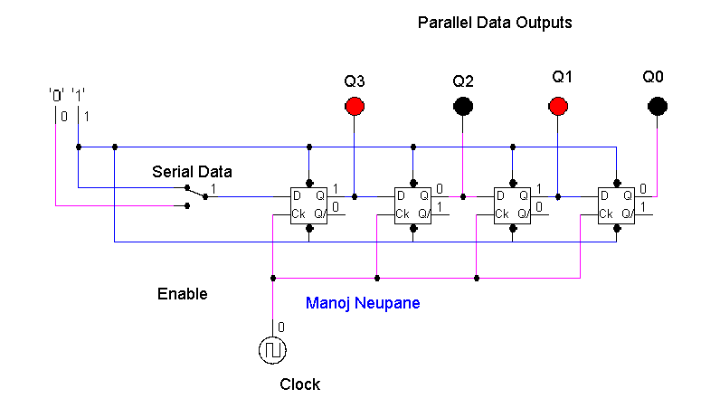

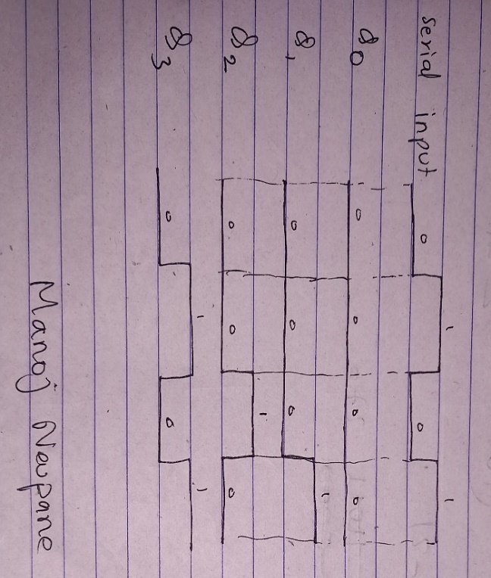
Timing Diagram:

- Design a 3-bit counter using Toggle D flip flop and draw the timing diagram.
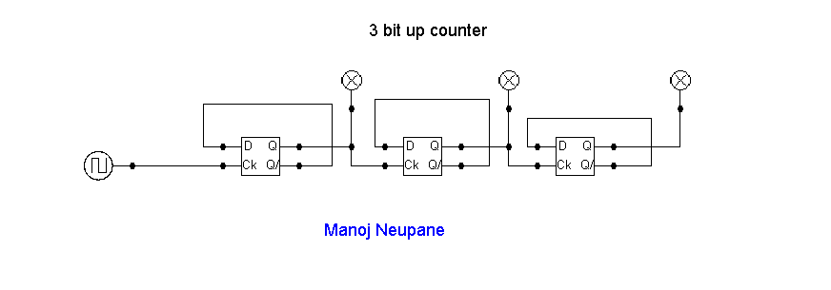

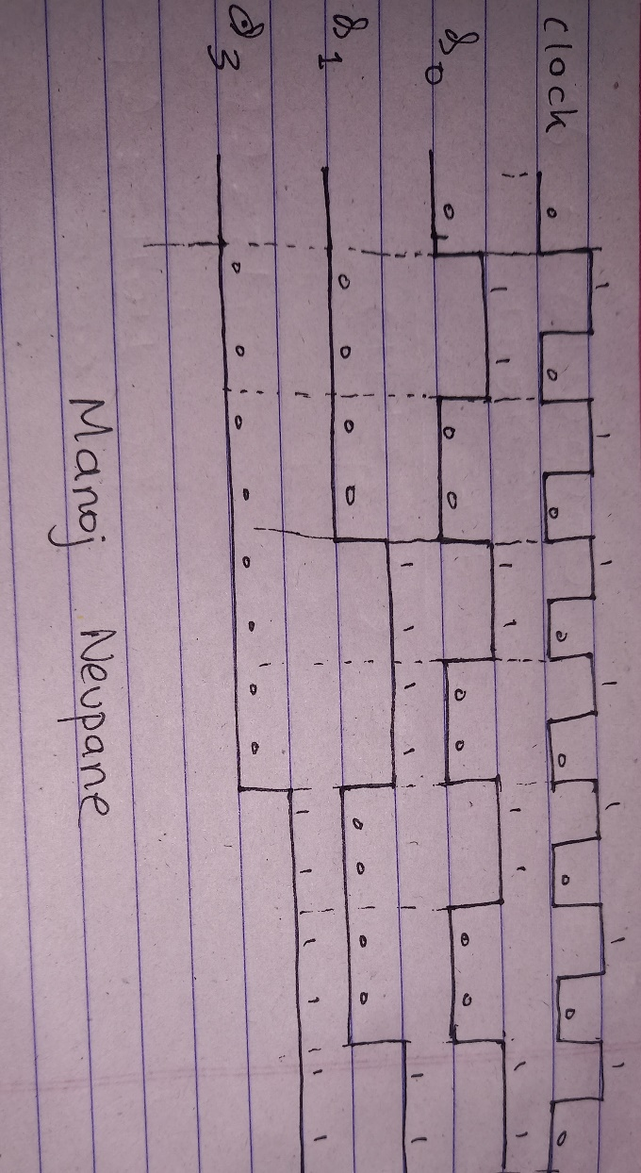

Timing Diagram:

- Load alu.cct file from the logsim folder. The circuit should look like this

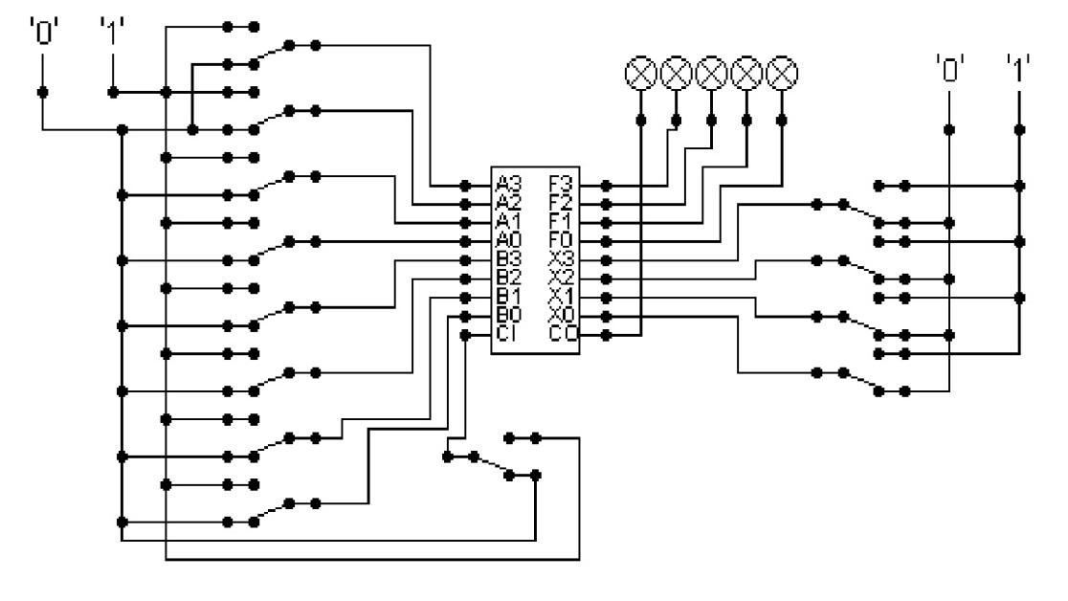
The circuit behaves like a simple arithmetic logic unit. The inputs A0-A3 represent a 4 bit binary number. Inputs B0-B3 represent another binary number. A0 and B0 are the least significant bits respectively. The following table details the functions supported by the chip. All other control lines = 0.
Function | Add | Subtract
X3-X0 | 1010 | 1011

- Use A= 15 and B = 7

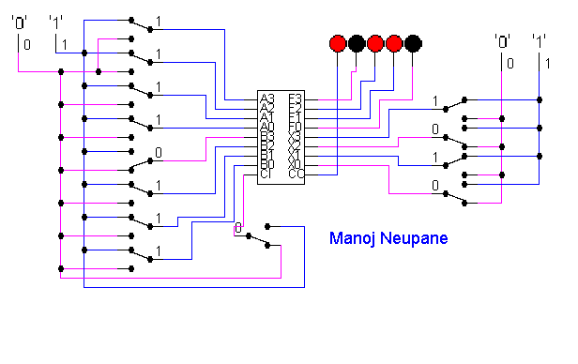

Carry | 1 | 1 | 1 | -
A | 1 | 1 | 1 | 1
B | 0 | 1 | 1 | 1
Sum | 0 | 1 | 1 | 0

Here the output is 0110 and the left bit 1 is an overflow.

- Use A = 13 and B = 9
Write the corresponding result of the operations. Manually provide each operation has provided the correct result.

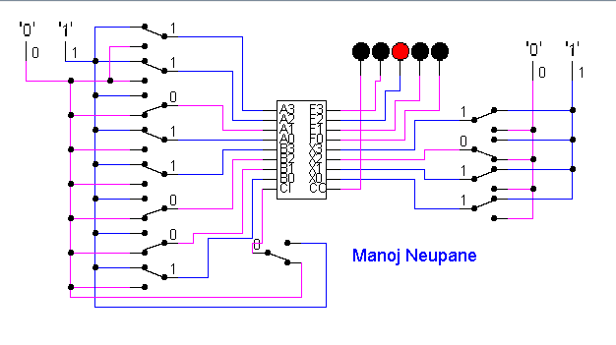
A | 1 | 1 | 0 | 1
B | 1 | 0 | 0 | 1
Difference | 0 | 1 | 0 | 0

